# Multiplexing

Multiplexing is a technique used to combine and send the multiple data streams over a single medium. The process of combining the data streams is known as multiplexing and hardware used for multiplexing is known as a multiplexer (MUX).

Demultiplexing is achieved by using a device called Demultiplexer (**DEMUX**) available at the receiving end. DEMUX separates a signal into its component signals (one input and n outputs).

# Concept of Multiplexing

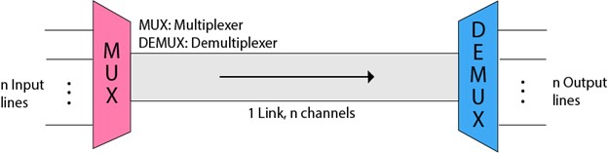 o The 'n' input lines are transmitted through a multiplexer and multiplexer combines the signals to form a composite signal. o The composite signal is passed through a Demultiplexer and demultiplexer separates a signal to component signals and transfers them to their respective destinations.

**Advantages of Multiplexing:**

o More than one signal can be sent over a single medium. o The bandwidth of a medium can be utilized effectively.

# Multiplexing Techniques

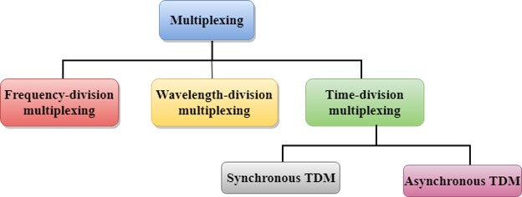

# Frequency-division Multiplexing (FDM)

It is an analog technique. **Frequency Division Multiplexing** is a technique in which the available bandwidth of a single transmission medium is subdivided into several channels.

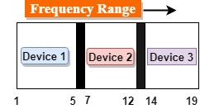

In the above diagram, a single transmission medium is subdivided into several frequency channels, and each frequency channel is given to different devices. Device 1 has a frequency channel of range from 1 to 5.

The input signals are translated into frequency bands by using modulation techniques, and they are combined by a multiplexer to form a composite signal.

The main aim of the FDM is to subdivide the available bandwidth into different frequency channels and allocate them to different devices.

**Applications Of FDM:**

o FDM is commonly used in TV networks. o It is used in FM and AM broadcasting.

# Wavelength Division Multiplexing (WDM)

Wavelength Division Multiplexing is same as FDM except that the optical signals are transmitted through the fibre optic cable. WDM is used on fibre optics to increase the capacity of a single fibre. It is used to utilize the high data rate capability of fibre optic cable. It is an analog multiplexing technique.

Optical signals from different source are combined to form a wider band of light with the help of multiplexer. At the receiving end, demultiplexer separates the signals to transmit them to their respective destinations.

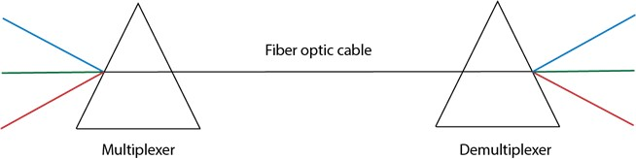

# Time Division Multiplexing

* It is a digital technique. In Frequency Division Multiplexing Technique, all signals operate at the same time with different frequency, but in case of Time Division Multiplexing technique, all signals operate at the same frequency with different time.
* In **Time Division Multiplexing technique**, the total time available in the channel is distributed among different users. Therefore, each user is allocated with different time interval known as a Time slot at which data is to be transmitted by the sender.
* A user takes control of the channel for a fixed amount of time.
* In Time Division Multiplexing technique, data is not transmitted simultaneously rather the data is transmitted one-by-one.
* In TDM, the signal is transmitted in the form of frames. Frames contain a cycle of time slots in which each frame contains one or more slots dedicated to each user.

**There are two types of TDM:**

* Synchronous TDM o Asynchronous TDM

## Synchronous TDM

* A Synchronous TDM is a technique in which time slot is preassigned to every device.
* In Synchronous TDM, each device is given some time slot irrespective of the fact that the device contains the data or not. If the device does not have any data, then the slot will remain empty.
* In Synchronous TDM, signals are sent in the form of frames. Time slots are organized in the form of frames. If a device does not have data for a particular time slot, then the empty slot will be transmitted.
* The most popular Synchronous TDM are T-1 multiplexing, ISDN multiplexing, and SONET multiplexing.
* If there are n devices, then there are n slots.

### Concept Of Synchronous TDM

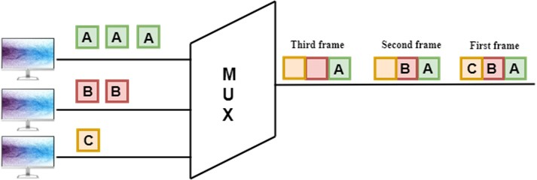

In the above figure, the Synchronous TDM technique is implemented. Each device is allocated with some time slot. The time slots are transmitted irrespective of whether the sender has data to send or not.

### Disadvantages Of Synchronous TDM

o The capacity of the channel is not fully utilized as the empty slots are also transmitted which is having no data.

## Asynchronous TDM

* An asynchronous TDM is also known as Statistical TDM.
* An asynchronous TDM is a technique in which time slots are not fixed as in the case of Synchronous TDM. Time slots are allocated to only those devices which have the data to send. Therefore, we can say that Asynchronous Time Division multiplexor transmits only the data from active workstations.
* An asynchronous TDM technique dynamically allocates the time slots to the devices.
* In Asynchronous TDM, total speed of the input lines can be greater than the capacity of the channel.
* Asynchronous Time Division multiplexor accepts the incoming data streams and creates a frame that contains only data with no empty slots.
* In Asynchronous TDM, each slot contains an address part that identifies the source of the data.
* The difference between Asynchronous TDM and Synchronous TDM is that many slots in Synchronous TDM are unutilized, but in Asynchronous TDM, slots are fully utilized. This leads to the smaller transmission time and efficient utilization of the capacity of the channel.

### Concept Of Asynchronous TDM

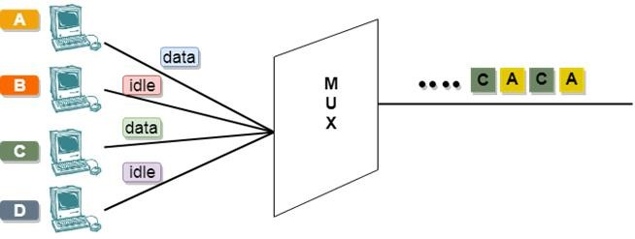

In the above diagram, there are 4 devices, but only two devices are sending the data, i.e., A and C. Therefore, the data of A and C are only transmitted through the transmission line.

# Error Detection

When data is transmitted from one device to another device, the system does not guarantee whether the data received by the device is identical to the data transmitted by another device. An Error is a situation when the message received at the receiver end is not identical to the message transmitted.

## Types Of Errors

## Single-Bit Error:

The only one bit of a given data unit is changed from 1 to 0 or from 0 to 1.

## Burst Error:

The two or more bits are changed from 0 to 1 or from 1 to 0 is known as Burst Error.

## Error Detecting Techniques: (Read more)

The most popular Error Detecting Techniques are:

* Single parity check
* Two-dimensional parity check
* Checksum
* Cyclic redundancy check

# Error Correction

Error Correction codes are used to detect and correct the errors when data is transmitted from the sender to the receiver.

Error Correction can be handled in two ways:

* **Backward error correction:** Once the error is discovered, the receiver requests the sender to retransmit the entire data unit.
* **Forward error correction:** In this case, the receiver uses the error-correcting code which automatically corrects the errors.

# Network Layer Protocols

TCP/IP supports the following protocols:

## ARP - Address Resolution Protocol.

## RARP - **Reverse Address Resolution Protocol**.

* ICMP - Internet Control Message Protocol
* IGMP - Internet Group Message Protocol.

### ARP

If the host wants to know the physical address of another host on its network, then it sends an ARP query packet that includes the IP address and broadcast it over the network. Every host on the network receives and processes the ARP packet, but only the intended recipient recognizes the IP address and sends back the physical address. The host holding the datagram adds the physical address to the cache memory and to the datagram header, then sends back to the sender.

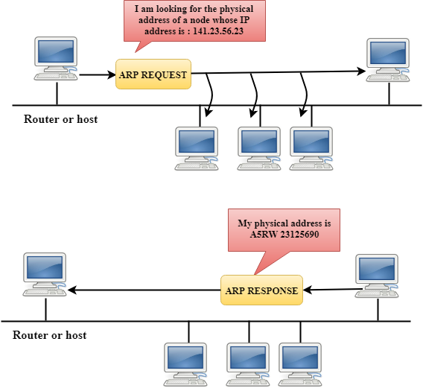

## RARP

* RARP stands for **Reverse Address Resolution Protocol**.
* If the host wants to know its IP address, then it broadcast the RARP query packet that contains its physical address to the entire network. A RARP server on the network recognizes the RARP packet and responds back with the host IP address.
* The protocol which is used to obtain the IP address from a server is known as **Reverse Address Resolution Protocol**.
* The message format of the RARP protocol is similar to the ARP protocol.
* Like ARP frame, RARP frame is sent from one machine to another encapsulated in the data portion of a frame.

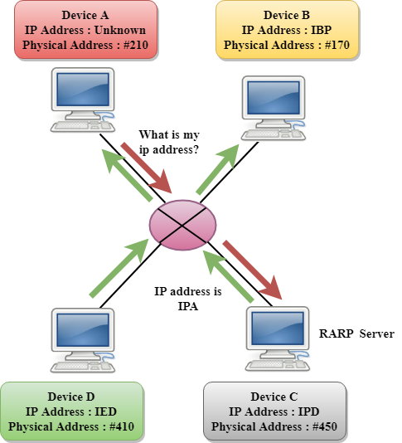

## ICMP

* ICMP stands for Internet Control Message Protocol.
* The ICMP is a network layer protocol used by hosts and routers to send the notifications of IP datagram problems back to the sender.
* ICMP uses echo test/reply to check whether the destination is reachable and responding.
* ICMP handles both control and error messages, but its main function is to report the error but not to correct them.
* An IP datagram contains the addresses of both source and destination, but it does not know the address of the previous router through which it has been passed. Due to this reason, ICMP can only send the messages to the source, but not to the immediate routers.
* ICMP protocol communicates the error messages to the sender. ICMP messages cause the errors to be returned back to the user processes.
* ICMP messages are transmitted within IP datagram.
* IGMP stands for **Internet Group Message Protocol**.
* The IP protocol supports two types of communication:
  + **Unicasting:** It is a communication between one sender and one receiver. Therefore, we can say that it is one-to-one communication.
  + **Multicasting:** Sometimes the sender wants to send the same message to a large number of receivers simultaneously. This process is known as multicasting which has one-to-many communication.
* The IGMP protocol is used by the hosts and router to support multicasting.
* The IGMP protocol is used by the hosts and router to identify the hosts in a LAN that are the members of a group.

